**Problem Statement – 1**

/*

a) Write a program in java to check if a class can extends another class and can implement one and more than one interface.

b) Write a program in java to check if an interface can extend other interface.

c) Write a program in java to check if an interface can also extend multiple interfaces.

*/

/**

 * practical_6_problem_statement_1

 */

interface interface1 {

    void display1();

}

interface interface2 extends interface1 {

    void display2();

}

interface interface3 extends interface1, interface2 {

    void display3();

}

class class1 {

    void display() {

        System.out.println("This is class1.");

    }

}

class class2 extends class1 implements interface1, interface2 {

    @Override

    public void display() {

        System.out.println("This is class2.");

    }

    public void display1() {

        System.out.println("This is interface1 display function.");

    }

    public void display2() {

        System.out.println("This is interface2 display function.");

    }

}

public class practical_6_problem_statement_1 {

    public static void main(String[] args) {

        class2 c = new class2();

        c.display();

        c.display1();

        c.display1();

    }

}

**Output:**

**Problem Statement – 2**

**Circle Class File**

interface GeometricalObject {

    double getPerimeter();

    double getArea();

}

class Circle implements GeometricalObject {

    double radius = 1.0;

    public Circle() {

    }

    public Circle(double r) {

        this.radius = r;

    }

    public double getPerimeter() {

        return 2 * Math.PI * this.radius;

    }

    public double getArea() {

        return Math.PI * this.radius * this.radius;

    }

}

**ResizableCircle Java File**

interface Resizeable {

    void resize(int percent);

}

class ResizableCircle extends Circle implements Resizeable {

    public ResizableCircle() {

        super();

    }

    public void resize(int percent) {

        double p = percent;

        double new_radius = this.radius + this.radius * p / 100;

        this.radius = new_radius;

    }

}

**Main Java File**

/*

Define the interface / class hierarchy as detailed in the following class diagram

Definition of Done:

DOD 1: The class definitions are defined as per the class diagram.

DOD 2: Each class definition is stored in its own .java file.

DOD 3: Base class constructors are invoked using super keyword

DOD 4: Function overriding is applied wherever applicable.

*/

/**

 * practical_6_problem_statement_2

 */

public class practical_6_problem_statement_2 {

    public static void main(String[] args) {

        ResizableCircle rc = new ResizableCircle();

        rc.radius = 5;

        System.out.print("\nArea: " + rc.getArea());

        System.out.print("\nPerimeter: " + rc.getPerimeter());

        System.out.print("\n\nAfter Resizing Circle");

        System.out.println(rc.radius);

        System.out.println();

        System.out.print("\nArea: " + rc.getArea());

        System.out.print("\nPerimeter: " + rc.getPerimeter());

    }

}

**Output:**

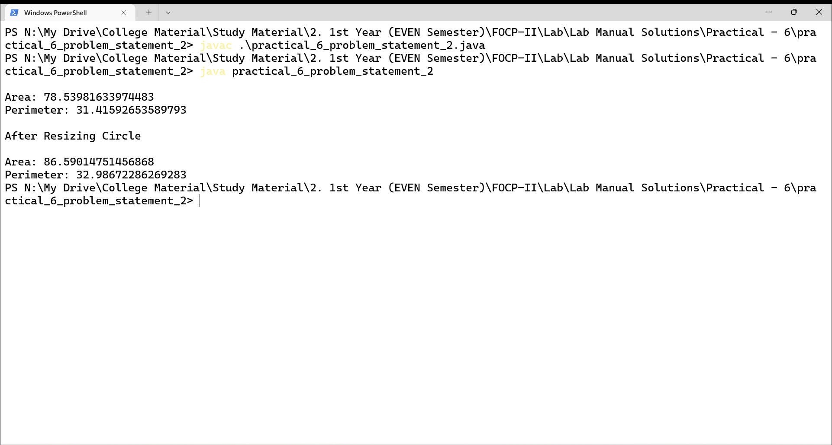

**Problem Statement - 3**

/*

We have to calculate the area of a rectangle, a square and a circle. Create an abstract class 'Shape' with three abstract methods namely 'RectangleArea' taking two parameters, 'SquareArea' and 'CircleArea' taking one parameter each. The parameters of 'RectangleArea' are its length and breadth, that of 'SquareArea' is its side and that of 'CircleArea' is its radius. Now create another class 'Area' containing all the three methods 'RectangleArea', 'SquareArea' and 'CircleArea' for printing the area of rectangle, square and circle respectively. Create an object of class 'Area' and call all the three methods.

*/

/**

 * practical_6_problem_statement_3

 */

abstract class Shape {

    abstract double RectangleArea(double l, double b);

    abstract double SquareArea(double s);

    abstract double CircleArea(double r);

}

class Area extends Shape {

    double RectangleArea(double length, double breadth) {

        return length * breadth;

    }

    double SquareArea(double side) {

        return side * side;

    }

    double CircleArea(double radius) {

        return Math.PI * radius * radius;

    }

}

public class practical_6_problem_statement_3 {

    public static void main(String[] args) {

        Area a = new Area();

        System.out.println("Area of Rectangle: " + a.RectangleArea(5, 7));

        System.out.println("Area of Square: " + a.SquareArea(6));

        System.out.println("Area of Circle: " + a.CircleArea(8));

    }

}

**Output:**

